1. SELECT CONCAT(FName,' ',LName) as FullName FROM instructor WHERE Degree='PhD'

1. SELECT CONCAT(FName,' ',LName) AS Name FROM phdstudent WHERE StudentId IN (SELECT StudentId FROM gta); A screenshot of a computer

   Description automatically generated
2. SELECT CName FROM course WHERE CourseID IN (SELECT CourseID FROM coursestaught WHERE InstructorId='BL9856');  
   A screenshot of a computer

   Description automatically generated
3. SELECT instructor.InstructorId, ifnull(tt.NoOfPhDStudents,0) as NoOfPhDStudents FROM ( instructor LEFT OUTER JOIN tt ON instructor.InstructorId = tt.InstructorId ); 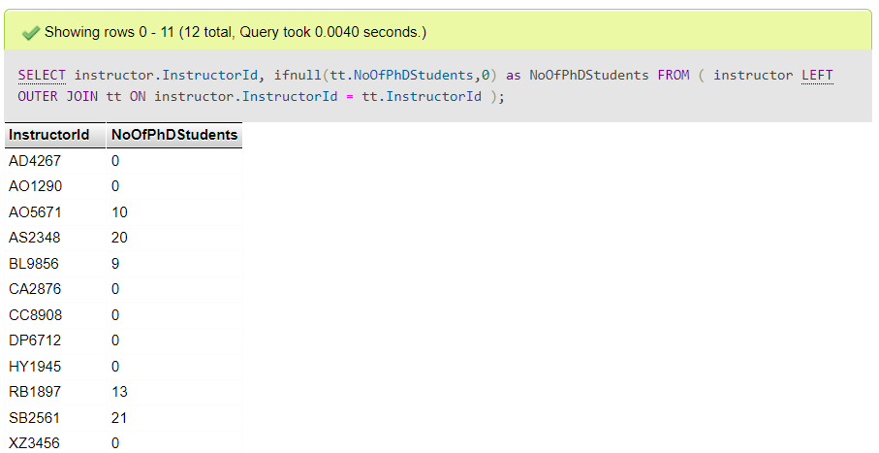
4. SELECT * FROM phdstudent WHERE phdstudent.StudentId in (select milestonespassed.StudentId from milestonespassed WHERE milestonespassed.MId='CM');

1. select * from GRANTS where YEAR(grants.StDate)=2018;  
   A screenshot of a computer

   Description automatically generated
2. select * from phdstudent WHERE phdstudent.StudentId in (select selfsupport.StudentId from selfsupport);

1. SELECT StudentId, MonthlyStipned FROM scholarshipsupport;

9. select Instructor.InstructorId from instructor where instructor.InstructorId not in (SELECT DISTINCT(phdcommittee.InstructorId) from phdcommittee);  
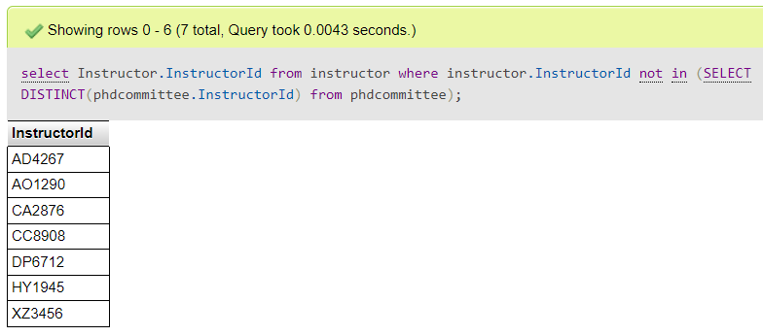

10. select course.CourseID,course.CName from course where course.CourseID not in (select DISTINCT(coursestaught.CourseID) from coursestaught);

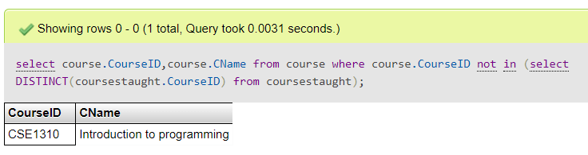

11. select avg(gra.MonthlyPay) as AvgMonthlyPay,gra.MajaorResearchArea from gra group by gra.MajaorResearchArea;

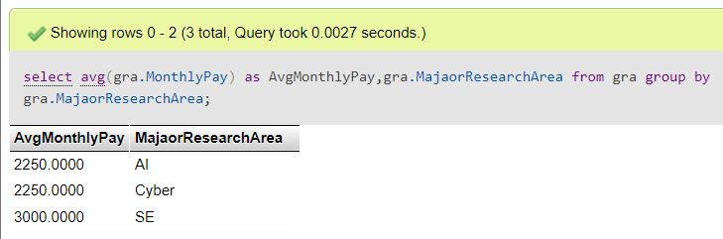

12. select count(section.SectionId) as TotalSection,instructor.FName,instructor.LName from section JOIN instructor on section.InstructorId=instructor.InstructorId GROUP BY section.InstructorId;

13. select * from phdstudent where phdstudent.StudentId in (select scholarshipsupport.StudentId from scholarshipsupport where scholarshipsupport.ScholarshipID in (SELECT scholarship.ScholarshipID from scholarship where scholarship.FundingOrganization like '%National Science Foundation%'));

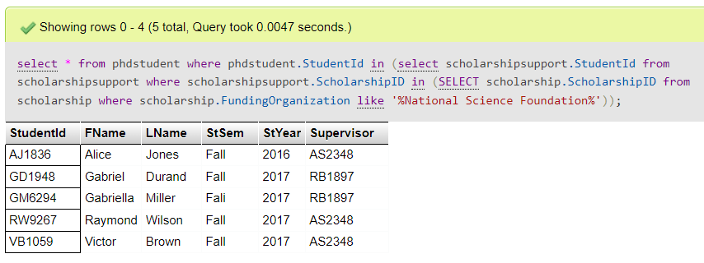

14. DELETE FROM phdstudent WHERE phdstudent.StudentId='AA1234';

**Message**: Cannot delete or update a parent row: a foreign key constraint fails (`doctoral`.`milestonespassed`, CONSTRAINT `milestonespassed_ibfk_1` FOREIGN KEY (`StudentId`) REFERENCES `phdstudent` (`StudentId`))

15. UPDATE instructor SET instructor.InstructorId='AA1111' WHERE instructor.InstructorId='AO5671';  
**Message:** Cannot delete or update a parent row: a foreign key constraint fails (`doctoral`.`coursestaught`, CONSTRAINT `coursestaught_ibfk_2` FOREIGN KEY (`InstructorId`) REFERENCES `instructor` (`InstructorId`))

16. **(a) Violates Key Constraint**

INSERT INTO phdstudent(StudentId, FName, LName, StSem, StYear, Supervisor) VALUES ('AA2345','Sakshi','Patel','Fall','2017','AO5671');  
**Message:** Duplicate entry 'AA2345' for key 'PRIMARY'

**(b) Violates Entity Integrity Constraint**INSERT INTO phdstudent(StudentId, FName, LName, StSem, StYear, Supervisor) VALUES (null,'Sakshi','Patel','Fall','2017','AO5671');

**Message:** Column 'StudentId' cannot be null

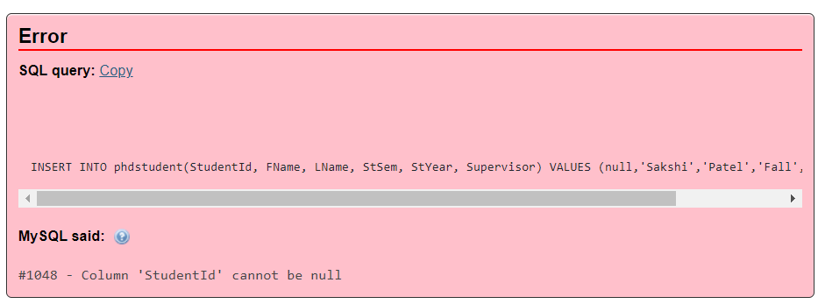

**(c)Violates Referential Integrity Constraint**

INSERT INTO scholarshipsupport(StudentId, ScholarshipID, MonthlyStipned, Category) VALUES ('AA1234','SCH1011','1200.00','local');

**Message:** Cannot add or update a child row: a foreign key constraint fails (`doctoral`.`scholarshipsupport`, CONSTRAINT `scholarshipsupport_ibfk_1` FOREIGN KEY (`ScholarshipID`) REFERENCES `scholarship` (`ScholarshipID`))

